Solutions for trash levels :

- Ultrasonic range finders
(EZ0, EZ1, EZ2, EZ3, and EZ4 with progressively narrower beam angles).
https://www.sparkfun.com/products/639

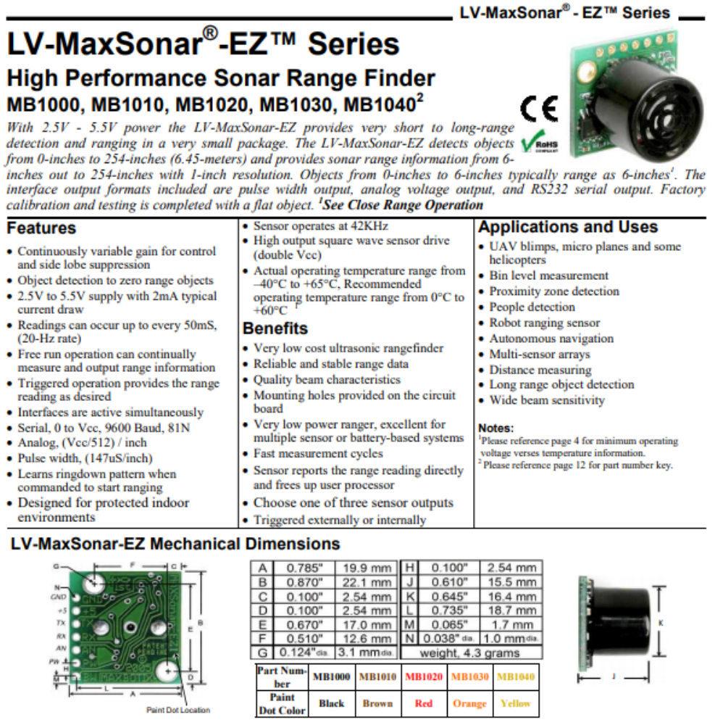
There's also the XL series features higher resolution, longer range, higher power output and better calibration when compared to the LV version but are more expensive.
Also comes in EZ0, EZ1, EZ2, EZ3, and EZ4 with progressively narrower beam angles.

There's also the HR models which have a higher resolution.
Also comes in EZ0, EZ1, EZ2, EZ3, and EZ4 with progressively narrower beam angles.

Finally, there's the WR models which are weather resistant (comes in XL and HRXL).

- Infrared proximity sensor
(Comes in Short, Medium and Long range).
https://www.sparkfun.com/products/8958

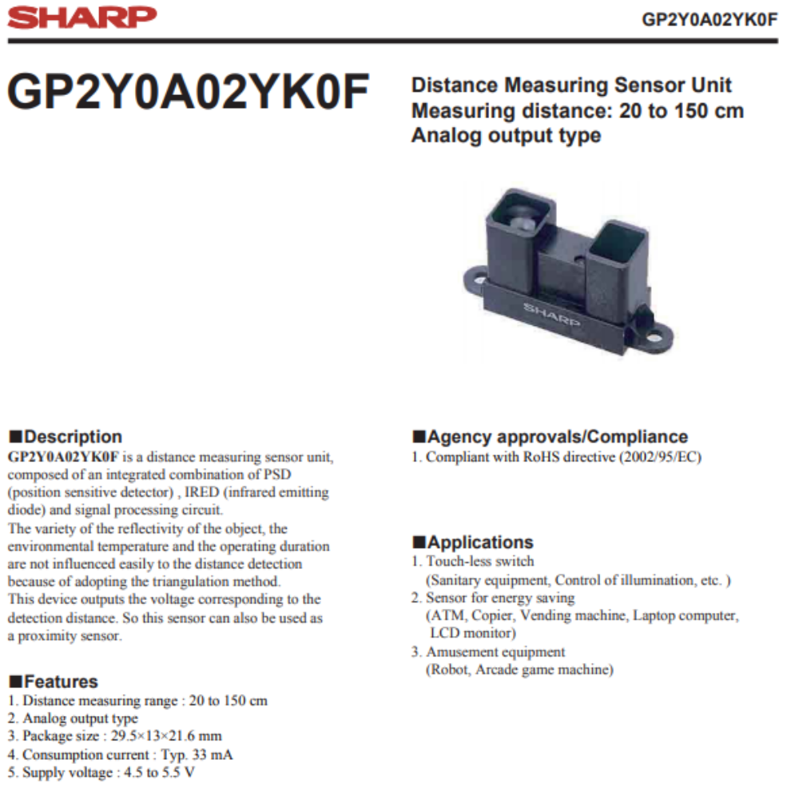

Short Range model: from 3.1V at 4cm to 0.3V at 30cm

Medium Range model: from 3.1V at 10cm to 0.4V at 80cm

Long Range model: from 2.8V at 15cm to 0.4V at 150cm

